1CAN Youth Advisory Board Application
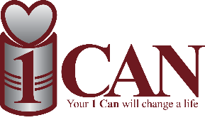
The mission of 1CAN.INC
Is to reduce the number of children, adults & families suffering from food insecurity.

The 1Can Youth Advisory Board members will serve as a liaison to the 1CAN.INC Executive Board. The 1Can board will support the work of the Youth Advisory Board and provide mission-based leadership and strategic governance. While day to day operations will be led by the 1Can Executive Board along with the 1CAN board member as the Youth Board Advisor. The Executive Board and Youth Advisory board relationship is a partnership, and appropriate involvement to have 1CAN mission to exceed.
1CAN Youth Advisory Board will serve 11-month term September-July. Applicants must be upstanding and current students in 8th grade – 12th grade from their communities, have good grades, and have the proper etiquette when serving for 1CAN.
Applications open April 1st- June 30th - deadline of June 30th Applicants will interview for Youth Advisory Board in the month of August. Youth Advisory Board will consist of no less than 6 and no more than 8 active members. Youth advisory Board are to attend all monthly meetings only allowing 2 to be missed during term. Youth Advisory Board is expected to volunteer 2/3 times a month for 1CAN, attend all fundraisers (missing one is allowed) and they are to come up with one fundraiser idea during their term.
(Please download application and email to Jenn Williams at jenn@your1can.org)

(First, Middle, Last name)

Current school

Date

Signature

_____
Address

City, State, Zip

How did you learn about this opportunity?

Please describe any work or volunteer/community service experience you have had (if any).

Please describe your involvement in school and community activities that have provided you the most opportunities to grow and learn.

Please describe your leadership experience.

What are your hobbies and personal interests?

Have you worked with 1Can.org before if so please explain?

